Appreciation Carnation |  |  | Appreciation Carnation
Teacher: |  |  | Teacher:
Student: |  |  | Student:
Message: |  |  | Message:
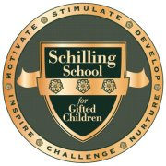

Appreciation Carnation |  |  | Appreciation Carnation
Teacher: |  |  | Teacher:
Student: |  |  | Student:
Message: |  |  | Message:

