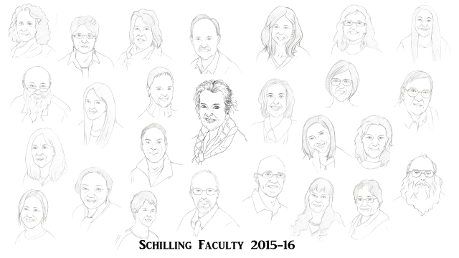
Gratitude Gram
May 6, 2016
Teacher: | Student:
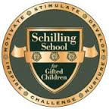Message:

Artist: Xingyao “Lucy” Wang

